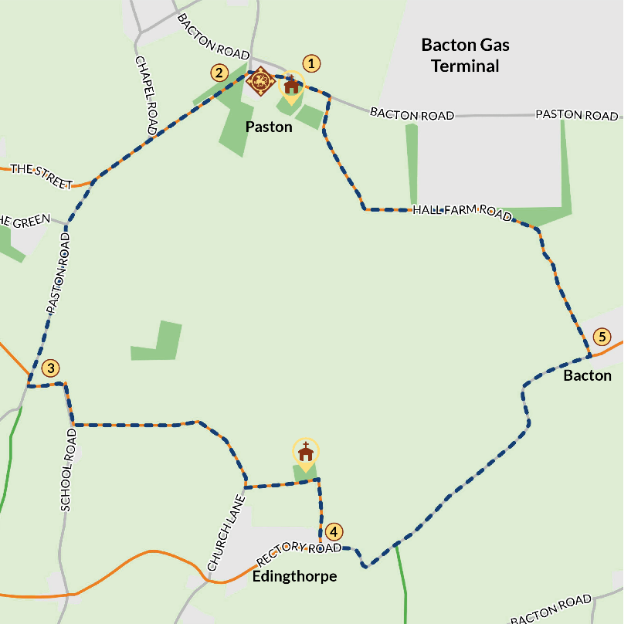 Paston Walk
Follow the path up to Paston Church Go round the back of St Margaret's to find the south porch church entrance.
Stop 1: Explore Paston Church
Inside St Margaret's Church can you spot:
- a 14th century painting of St Christopher carrying the Christ child across the river;
- 5 Paston tombs and memorials;
- a griffin (the Paston family symbol);
- read some of the Paston letters.
Leaving the church you will see a covered gateway, called a 'lychgate', over to the righthand corner of the churchyard. The lychgate marks the original entrance to the church. The Paston family moved the road to the other side so people wouldn't walk past their house on the way to church. Agnes Paston argued with the villagers about the wall they built on the old road.
Stop 2: View a virtual reconstruction of Paston Hall via the website of phone app.
Walk back past the church and take the first left by the Paston Footprints waymarked sign. Walk down the wooded path and stop before you get to the barn.
Look over to the left to see Paston Hall, a late Georgian building built on the site of the original. Use the phone app or the Norwich Walk web page to see a 3D reconstruction of what the hall looked around 1600.
Admire the impressive Paston Barn
Turn to your right and see the thatched Great Barn of the Pastons, a threshing barn to store their grain, built by Judge William Paston in the 16th century. It is the longest surviving medieval barn in the country. The rich arable lands of Norfolk were partly the cause of the Paston good fortunes.
Can you find the plaque on the Paston Barn entrance?
Keep following the path past the barn. Do not enter, as there are protected Barbestelle bats in residence, Paston barn being only one of six maternity roosts in the UK. Please be quiet in this area.
Turn left out of the gate and walk along the lane. With no footpath, be mindful of the odd car. You are now on the Paston Way. To continue on the full walk route, skip the next step.
FAMILY FRIENDLY SHORT ROUTE: Take the first right up a slight hill to Paston village. Bear left when you enter the village and you will come across a play park. Continue walking up the path until you come to the duck pond at the edge of the village. Retrace your steps and return back to the churchyard and car park. This is the end of the shorter family friendly route (although you could visit Mundsley or Bacton beach nearby).
Continue along the lane and bear left to Paston Green (marked by Paston Parish Council noticeboard). As you walk, look over to your left across the farmland. Judge William Paston established his manor at Paston by purchasing much of the land between the three churches on this walk and the land that stretches inland from here towards Witton Woods and North Walsham.
Keep following the road round to the left. You will pass poles with bright orange tips, which indicate that the UK's main gas pipeline is passing underneath you! Turn left at the junction signposted to Edingthorpe via Quiet Lanes.
After turning left follow the road as it bears to the right. After 200 yards look for a Paston Footprints waymarked post signposting a left turn across the field on a grassy track. Follow the track across the fields, right past the farm buildings, re-join the country road and follow the track up towards Edingthorpe Church.
Stop 4: Edingthorpe All Saints Church, is a round towered church. The church contains a memorial to a William Call. He was a descendant of the Pastons’ bailiff Richard Calle, who settled in Bacton.
Follow the footpath past the church onto open fields. Turn right towards the farm and walk along the side of the field. Keep following the path through the farm until you meet the road. Turn left and follow Rectory Road as it bends round to the left.
STOP 5: Bacton. As you come to the end of the road with a thatched barn in front of you, take a left and walk towards the Bacton Gas Terminal in the distance. At this stage you could extend the walk into Bacton. (There is another Bacton Paston walk taking you to Bromholm Priory that will return you to this point of the Paston walk).
Follow the path alongside the gas terminal and the road as it bends towards the right. You'll see Paston Barn in the distance signalling you are approaching the end of the walk. Walk along the road until it reaches the main coast road. Be careful as you take a left and walk along this busier road for a few yards until you come full circle and you reach your starting point.

