Norwich Walk

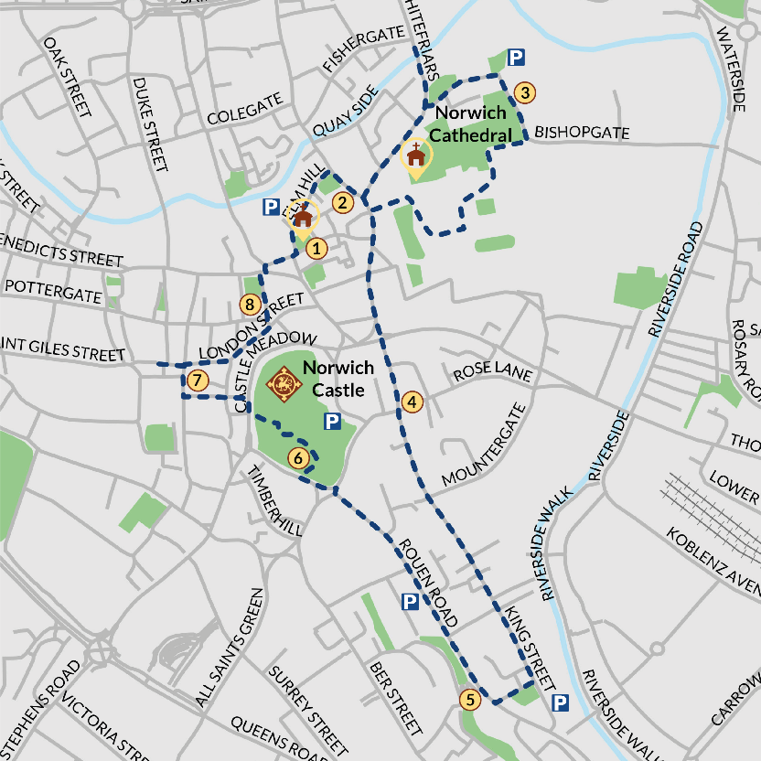
SHORT ROUTE: stops 1 – 3.

STOP 1: St Peter Hungate Church
Start at the Church at the top of Elm Hill, see the Paston corbels inside.

Walk down Elm Hill to Strangers' Club, the site of the Pastons’ house, which is about half way down the cobbled hill.

STOP 3: Maid’s Head Hotel
At the bottom of Elm Hill, turn right toward the Cathedral and pass the hotel on the corner on the left.

Walk towards the Cathedral and under the main Erpingham Gate into the Cathedral Close.

Bear right across the Cathedral Close and take the path past the statue of Nelson. At the far side of the close, take a left and walk past the herb garden to the square with a green. Take a left back towards the south gate of the cathedral. To the left through the archway enter the Cathedral Cloisters.

Explore the cloisters. Enjoy the labyrinth. Make sure you look up and admire the decorated ceiling.

Leave the cloisters and return to the south gate of the cathedral. Can you see roosting peregrines?

With the south gate in front of you, turn right and continue round the side of the cathedral. Just past Edith Cavell’s grave, you will reach the ruined chapel where Judge William Paston was buried.

Leave the Cathedral Close at the bottom exit by the flint wall. You'll see a sign for Bishopsgate.

Turn left as you come through the gates and follow the road past the Adam & Eve pub, one of the oldest in the city. Continue down Bishopgate, passing St Martin at Palace Plain Church on your right. At the T-junction you have the option to take a short detour to Whitefrairs Bridge.

STOP 3: Walk to Whitefrairs Bridge.

The area in front of you and to your right on the opposite side of the river is the site of the Whitefriars Priory where Agnes, and her son Clement were buried. Almost nothing remains.

Continue down Palace Street and back to Tombland, bearing left at the Maid's Head
Walk past the main cathedral gate you entered before and stop a few hundred yards further in front of the south gate of the Cathedral pictured here. This gate is over 1000 years old and see if you can spot the dragons. Dragons feature in the city’s history as the Guild of St George were a powerful institution in medieval Norwich, with members including Judge William Paston and son John Paston.

Continue onto upper King Street and cross over using the traffic lights on Prince of Wales road into King Street
Cross over across another junction and continue along King Street. There are some community and independent cafes along King Street where you can get a coffee or lunch.

MEDIUM ROUTE: add stops 4 – 6
Turn back and retrace your steps to the junction with Bishopgate. Continue down Palace Street and back to Tombland, near the Maid’s Head. Turn left and pass the Erpingham Gate, keeping on until you reach Upper King Street.

Stop 4: Heydon’s Tudor House
Continue across Princes of Wales street into King Street. Continue along King Street for 200 yards and you will reach Mountergate on the left. On the right is a Tudor house formerly owned by the Heydons, once enemies of the Pastons until Bridget Heydon married William Paston in 1502.

After walking around 200 yards on King Street you will reach Mountergate on the left. The white house on the corner here was the Tudor house formerly owned by the Heydons, once enemies of the Pastons until Bridget Heydon married William Paston in 1502.

Continue along King Street to Dragon Hall
Dragon Hall is on the site of an impressive merchants' hall owned by Robert Toppes, a friend of the Pastons in the 15th century. The Pastons traded from this part of the river (behind Dragon Hall).

Stop 5: Continue along King Street until you reach the Music House
The Music House was owned by John Paston III and later by William Paston.

Retrace your steps past Music House Lane and take St Julian’s Alley on your left.
Pass St Julian’s Shrine on your left before emerging on to Rouen Road. Turn right and walk to the end of the road. Cross the road and continue along Farmers Avenue opposite for a short while, then turn right into the Castle Green gardens. From here you can visit the Castle Museum (there is a fee, and during Covid restrictions you need to pre-book). Or have a picnic in the gardens, there is a slide and seesaw for children.

LONG ROUTE: stops 7, 8 and 1.
From the Castle go down in the lift outside and turn right on to Castle Meadow.

Stop 7: medieval market
Turn right and cross by the lights, then continue ahead down Davey Place and on to Gentleman’s Walk, where you will see the medieval market (much reconstructed). Turn right and after 50 metres or so you will see the Guildhall on your left. This was built in the first half of the 15th century and housed the law courts.

Stop 8: St Andrew’s Hall
Turn right and walk up London Street until you reach St Andrew’s Hill.
Turn left, and at the bottom you will find an open space and a large hall. This is St Andrew’s Hall adjoining Blackfriars Hall. The Pastons paid for roof repairs in both halls, and provided the oak door to St Andrew’s Hall, which carry the crests of the Pastons and the Mautbys (Margaret Paston’s family).

As you come away from St Andrew’s Hall, turn left up Princes Street until you reach the junction with Elm Hill, and St Peter Hungate Church – your starting point.

