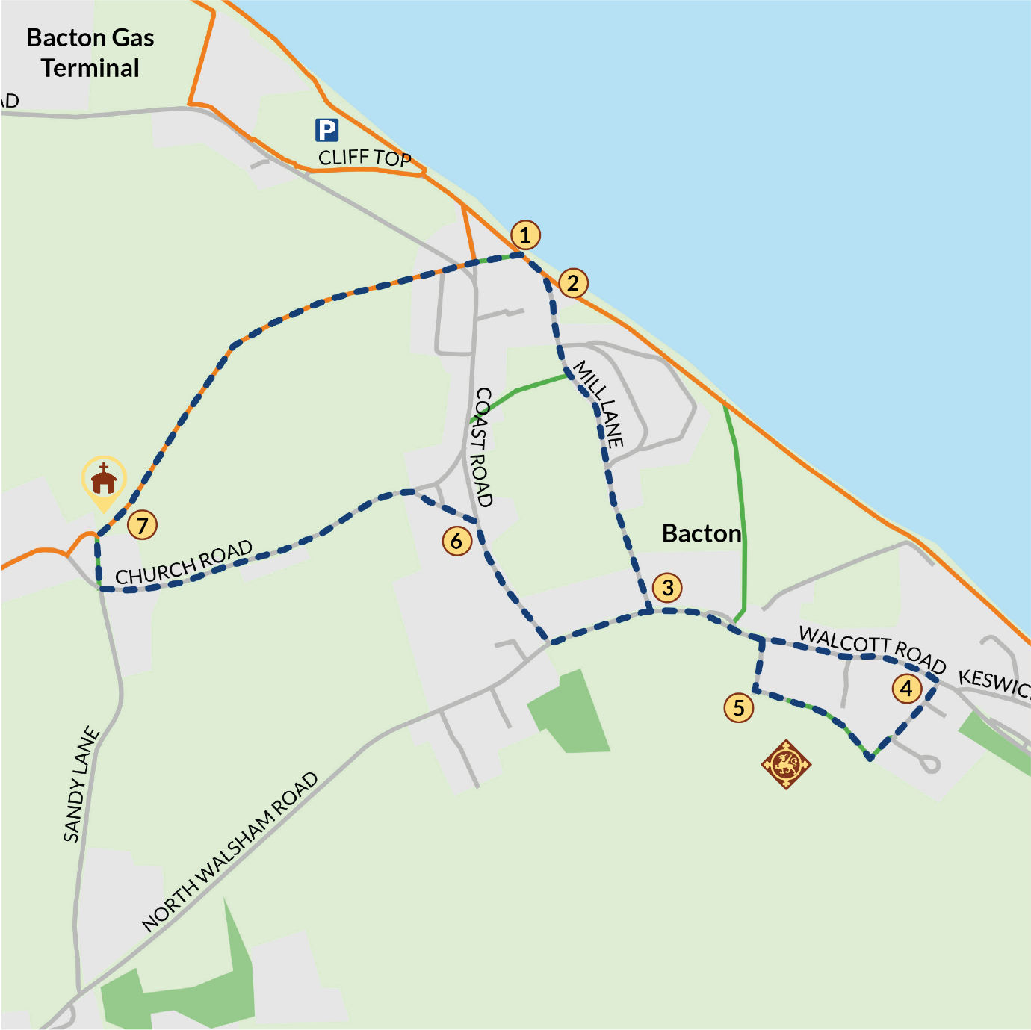

BACTON
- Park at the Local Authority Car Park, North of the village.
- Follow the beach to where you turn right into Mill Lane.
- Turn left on to coast road, then turn right up Abbey Street.
- Turn left at Priory Gate to follow the footpath to Priory Road.
- Turn left at the coast road, follow the coast road turning right at the junction.
- Take the first left up to Bacton Church.
- At Bacton Church follow the Paston Way back to the beach and retrace steps back to car park.

