Oxnead Walk
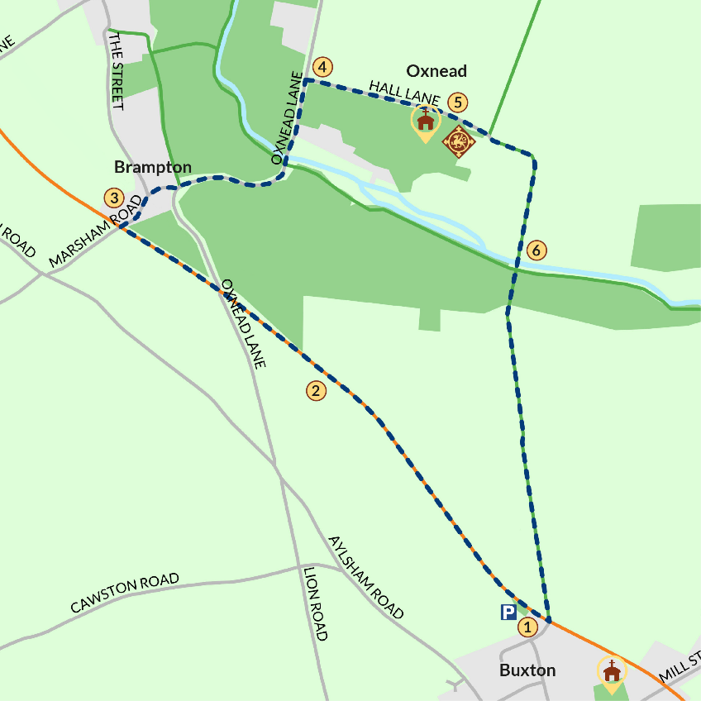
STOP 1: Park at the car park at the Bure Valley Railway Buxton stop.
Cross over the stile and with care cross over the small railway line to the path on the other side. Take a left and follow the Railway's trackside path down to the Brampton stop. As you cross over the Railway bridge look right across the River Bure: this was the site of Roman wharf that served the Roman settlement of Brampton. This area was excavated in the 17th century by Robert Paston.
STOP 2: At the Brampton Bure Valley Railway stop take the stairs down to the village.
Take a left at the foot of the stairs and walk away from the stairs towards the village of Brampton. At the junction turn right into Marsham Road and walk down through the village.
At the village sign bear left towards the bridge over the River Bure.
STOP 3: Walk over the bridge with the old mill dating back to the Doomsday Book of 1086) on your right and continue along the road. This is the Aylsham river navigation at Oxnead.
Around 250m up the road take the first right and turn up an ancient oak-lined road. Walk up a slight incline.
STOP 4: Take the path on the right for a short detour to explore Oxnead Church.
Sir Clement and his wife Alice, Katherine Paston, and Robert Paston are buried in Oxnead church.
STOP 5: Retrace your steps and continue on the path passing Oxnead Hall.
Oxnead Hall is now a private wedding venue so please admire it from the gate. You'll also be able to see further views of it later in the walk.
Good Judge William Paston bought Oxnead Hall in 1419 for his wife Agnes Paston. The Paston family continued to live at Oxnead for over 350 years until 1732.
Follow the path down past Oxnead Hall through farm buildings and bungalows.
Bear right at the big oak tree and follow path signposted to Keeper's Meadow alongside the hall.
STOP 6: Walk over the River Bure.
To extend your walk, take a left at the river and doing a wider circular route back to Buxton.
Or take a short detour on your right through the kissing gate and see another view of Oxnead Hall.
From here you can short-cut back to Brampton station by following the river back to the bridge, turning left and following your footsteps back through the village to the station.
Once over the river continue along the path up a slight incline.
Walk onto the open field and walk along the path past an evergreen line of trees. Keep walking straight through the next field towards Buxton Church in the distance and Buxton mill over on your left. After a few hundred yards you will finish where you started at the Railway trackside path.

